
Resource List and Order Form

Love Health - Hepatitis, HIV/AIDS & Sexual Health Program
Please send the completed form to:
Email: health@eccq.com.au
Fax: 07 3844 3122
Phone: 07 3844 9166
Web site: www.eccq.com.au/bbv
Hepatitis Resources
Resource |  | Language Available |  | Available Format | Quantity  required
B Healthy: My Guide To Chronic Hepatitis B  A5 Booklet  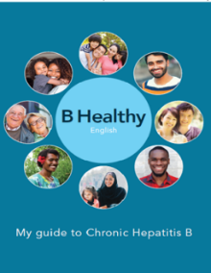  This booklet contains information for those who have been diagnosed with Hepatitis B and their families. |  | Arabic/English |  | Printed and PDF
 |  | Chinese/English |  | Printed and PDF
 |  | English |  | Printed and PDF
 |  | Korean/English |  | Printed and PDF
 |  | Vietnamese/English |  | Printed and PDF
Do you Have Chronic Hepatitis B Poster  A2 Poster  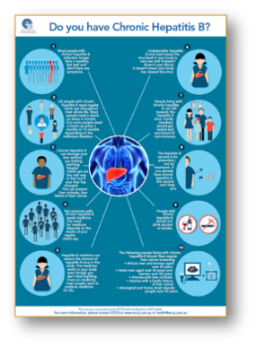  This poster lists key messages for people living with Chronic Hepatitis B |  | Chinese |  | Printed and PDF
 |  | English |  | Printed and PDF
 |  | Vietnamese |  | Printed and PDF
FibroScan Brochure For People Living With Hepatitis B Or C  DL size brochure  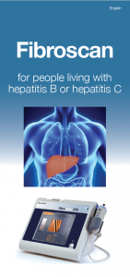  This brochure covers basic information about FibroScan and eligibility. |  | Traditional Chinese/English |  | Printed and PDF
 |  | Simplified Chinese/English |  | Printed and PDF
 |  | English |  | Printed and PDF
 |  | Korean/English |  | Printed and PDF
 |  | Vietnamese/English |  | Printed and PDF
Hepatitis B Brochure  DL size brochure  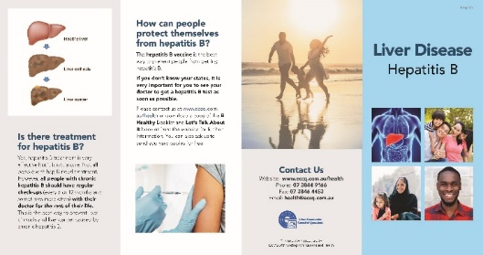  This brochure presents information on Hepatitis B |  | Arabic/English |  | Printed and PDF
 |  | Burmese/English |  | Printed and PDF
 |  | Traditional Chinese/English |  | Printed and PDF
 |  | Simplified Chinese/English |  | Printed and PDF
 |  | Dari/English |  | Printed and PDF
 |  | English |  | Printed and PDF
 |  | French/English |  | Printed and PDF
 |  | Hindi/English |  | Printed and PDF
 |  | Khmer/English |  | Printed and PDF
 |  | Kinyarwanda/English |  | Printed and PDF
 |  | Korean/English |  | Printed and PDF
 |  | Somali/English |  | Printed and PDF
 |  | Swahili/English |  | Printed and PDF
 |  | Tagalog/English |  | Printed and PDF
 |  | Thai/English |  | Printed and PDF
 |  | Vietnamese /English |  | Printed and PDF
 |  | Urdu/English |  | Printed and PDF
Hepatitis C Brochure  DL size brochure  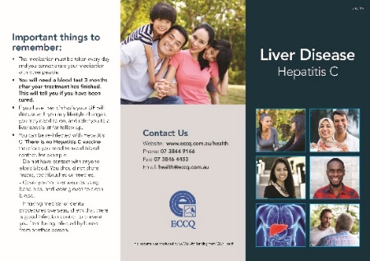  This brochure presents information on Hepatitis C. |  | Arabic/English |  | Printed and PDF
 |  | Burmese/English |  | Printed and PDF
 |  | Traditional Chinese/English |  | Printed and PDF
 |  | Simplified Chinese/English |  | Printed and PDF
 |  | Dari/English |  | Printed and PDF
 |  | English |  | Printed and PDF
 |  | French/English |  | Printed and PDF
 |  | Hindi/English |  | PDF only
 |  | Korean/English |  | Printed and PDF
 |  | Kinyarwanda/English |  | Printed and PDF
 |  | Somali/English |  | Printed and PDF
 |  | Swahili/English |  | Printed and PDF
 |  | Vietnamese/ English |  | Printed and PDF
 |  | Urdu/English |  | Printed and PDF
How to take Hepatitis B Medication in Australia  DL size brochure    This brochure presents information on Hepatitis B medication. |  | English |  | Printed and PDF
 |  | Arabic/English |  | Printed and PDF
 |  | Burmese/English |  | Printed and PDF
 |  | Simplified Chinese/English |  | Printed and PDF
 |  | Traditional Chinese/English |  | Printed and PDF
 |  | Dari |  | Printed and PDF
 |  | Hindi |  | Printed and PDF
 |  | Karen/English |  | Printed and PDF
 |  | Khmer |  | Printed and PDF
 |  | Korean/English |  | Printed and PDF
 |  | Swahili |  | Printed and PDF
 |  | Thai |  | Printed and PDF
 |  | Vietnamese/English |  | Printed and PDF
Eligibility for free Hepatitis B vaccine in Queensland  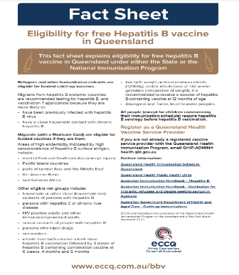  This fact sheet presents information on Hepatitis B vaccine in Queensland. |  | English |  | PDF only
Watch.Talk.Share.  Hepatitis B & C For You And Me Video  USB  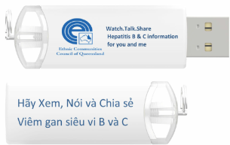  This USB contains a video explaining Hepatitis B and C in Vietnamese with English subtitles and digital versions of ECCQ resources in the Vietnamese language. |  | In Vietnamese with English Subtitle |  | USB and watch online:  www.eccq.com.au/watch
Sa ve Lives – Have A Liver Test Video  USB   |  | The video is available in English, Arabic, Burmese, Cantonese, Dari, Dinka, French, Juba Arabic, Karen, Kinyarwanda, Mandarin, Swahili, Vietnamese, and English with Korean subtitle. |  | USB and watch online:  www.eccq.com.au/whd
FibroScan Information Card  A7 Card  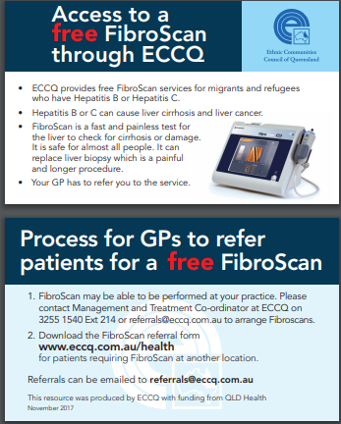  This card contains information on requesting a FibroScan through ECCQ. |  | Chinese/English |  | Printed and PDF
 |  | English |  | Printed and PDF
 |  | Korean/English |  | Printed and PDF
 |  | Vietnamese/English |  | Printed and PDF
HIV/AIDS Resources
Resource |  | Language Available |  | Available Format | Quantity required
HIV/AIDS Brochure  DL size brochure    This brochure presents information on HIV/AIDS. |  | Simplified Chinese / English |  | Printed and PDF
 |  | Dari / English |  | Printed and PDF
 |  | English |  | Printed and PDF
 |  | Hindi/English |  | PDF only
 |  | Vietnamese / English |  | Printed and PDF
Be In Control Brochure  A5 factsheet  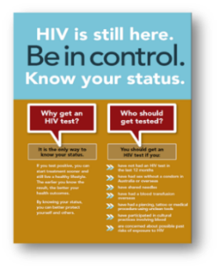  This brochure presents information on HIV testing. |  | Traditional Chinese/English |  | Printed and PDF
 |  | Simplified Chinese/English |  | Printed and PDF
 |  | English |  | Printed and PDF
 |  | Hindi/English |  | Printed and PDF
 |  | Tagalog/English |  | PDF only
 |  | Thai/ English |  | PDF only
 |  | Vietnamese/English |  | Printed and PDF
STI Resources
Resource |  | Language Available |  | Available Format | Quantity required
STI Brochure  DL size brochure    This brochure presents information on STIs. |  | Arabic/English |  | Printed and PDF
 |  | Simplified Chinese/English |  | Printed and PDF
 |  | Dari/English |  | Printed and PDF
 |  | Hindi/English |  | Printed and PDF
 |  | English |  | Printed and PDF
 |  | Korean/English |  | Printed and PDF
 |  | Vietnamese/English |  | Printed and PDF
Mpox Factsheet  DL size  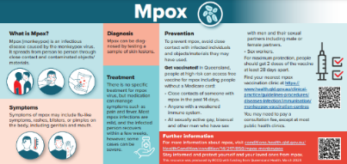  This brochure presents information about Monkeypox. |  | Arabic/English |  | Printed and PDF
 |  | Traditional Chinese/English |  | Printed and PDF
 |  | Simplified Chinese/English |  | Printed and PDF
 |  | English |  | Printed and PDF
 |  | Korean/English |  | Printed and PDF
 |  | Spanish/English |  | Printed and PDF
 |  | Thai/English |  | Printed and PDF
 |  | Vietnamese/English |  | Printed and PDF
BBV/STI Resources
Resource |  | Language Available |  | Available Format | Quantity required
Let’s Talk About It  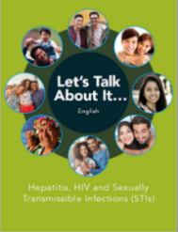  This booklet contains information on viral hepatitis, HIV and STIs. |  | Traditional Chinese/English  (DL size) |  | Printed and PDF
 |  | Simplified Chinese/English  (DL size) |  | Printed and PDF
 |  | English  (A5 booklet) |  | Printed and PDF
 |  | Korean/English  (DL size) |  | Printed and PDF
 |  | Vietnamese/English  (DL size) |  | Printed and PDF
ECCQ Program Brochures
Resource |  | Language Available |  | Available Format | Quantity required
ECCQ Hepatitis HIV/AIDS & Sexual Health Program  DL size brochure  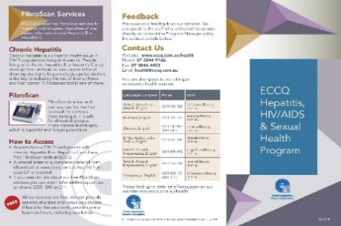  This brochure presents the program information. |  | Chinese/English |  | Printed and PDF
 |  | English |  | Printed and PDF
 |  | Korean/English |  | Printed and PDF
 |  | Vietnamese/English |  | Printed and PDF
Information To Our Clients  DL size brochure  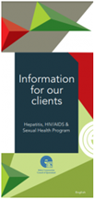  This brochure introduces our services and eligibility, privacy, confidential policy, and how to make feedback and complaints. |  | English |  | Printed and PDF
 |  | Traditional Chinese/English |  | Printed and PDF
 |  | Simplified Chinese/English |  | Printed and PDF
 |  | Korean/English |  | Printed and PDF
 |  | Vietnamese/English |  | Printed and PDF
Banner Pens
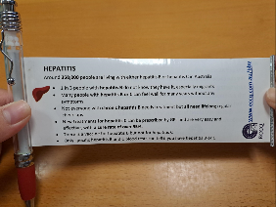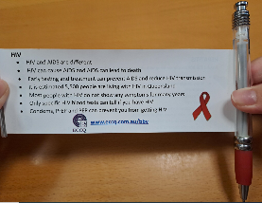  This banner pen has hepatitis and HIV messages. | Language Available |  | Quantity required (single pen)
 | Chinese
 | English
 | Korean
 | Vietnamese
Condom Packs
Condom Sample Pack  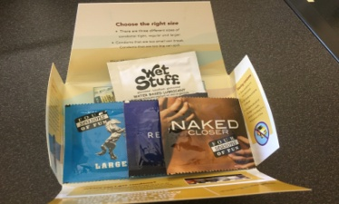  Each pack contains information on condoms, lubricant and three condom sizes (Small, Regular, Large). |  | Language on condom packs: English |  | Pack | Quantity required
 |  | Notes:

