FibroScan® with ECCQ

Client Name:__________________________________________________________________
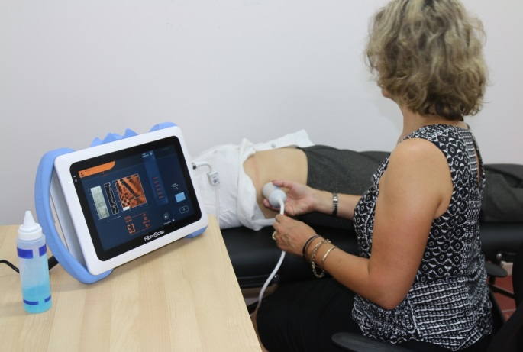
You have been referred by your doctor Dr.___________________________________________ to have a FibroScan® procedure with ECCQ. At ECCQ we provide FREE FibroScan® to check for potential damage to the liver caused by chronic hepatitis.
FibroScan® is a fast and painless type of ultrasound test of the liver performed by a trained operator. A bilingual community health care worker will usually be available to help with any questions you may have. Alternatively, an interpreter may be required to assist. Your doctor will discuss the result with you at your next appointment.
It is VERY important to have regular check-ups with your doctor and to have any tests which they may request if you have chronic hepatitis. Even if you feel well.
On the day of your FibroScan® you must:
- NOT EAT for 3 hours before your test. You can drink sips of water only.
Eating and drinking can affect the result.
- Wear comfortable clothing (skirt/pants and top) as the test is performed over your ribs on the right hand side.
- You must let us know before the test if you have a pacemaker or internal defibrillator in your heart.
- You must be over 18 years old to have this test.
Your appointment has been booked for:
Date: Day: Time:
Where:

It is important that you let the clinic know if you cannot come on this day.
If you have any questions about FibroScan® you can contact our ECCQ community health workers: 3844 6877 / 0479 130 997 for Chinese; 3844 3122 / 0428 223 052 for Vietnamese; or 3255 1540 Ext 214 for English and other languages.
Funding for this project provided by Queensland Health

FibroScan® with ECCQ

Client Name:__________________________________________________________________
You have been referred by your doctor Dr.___________________________________________ to have a FibroScan® procedure with ECCQ. At ECCQ we provide FREE FibroScan® to check for potential damage to the liver caused by chronic hepatitis.
FibroScan® is a fast and painless type of ultrasound test of the liver performed by a trained operator. A bilingual community health care worker will usually be available to help with any questions you may have. Alternatively, an interpreter may be required to assist. Your doctor will discuss the result with you at your next appointment.
It is VERY important to have regular check-ups with your doctor and to have any tests which they may request if you have chronic hepatitis. Even if you feel well.
On the day of your FibroScan® you must:
- NOT EAT for 3 hours before your test. You can drink sips of water only.
Eating and drinking can affect the result.
- Wear comfortable clothing (skirt/pants and top) as the test is performed over your ribs on the right hand side.
- You must let us know before the test if you have a pacemaker or internal defibrillator in your heart.
- You must be over 18 years old to have this test.
Your appointment has been booked for:
Date: Day: Time:
Where:

It is important that you let the clinic know if you cannot come on this day.
If you have any questions about FibroScan® you can contact our ECCQ community health workers: 3844 6877 / 0479 130 997 for Chinese; 3844 3122 / 0428 223 052 for Vietnamese; or 3255 1540 Ext 214 for English and other languages.
Funding for this project provided by Queensland Health

FibroScan® with ECCQ

Magaca Macamiilka:_____________________________________________________________
Waxaa ku soo gudbiyey dhakhtarkaaga Dr.___________________________________________ si aad u qaadatid nidaamka a FibroScan® ee ECCQ. At ECCQ waxaan bixinaynaa FibroScan® BILAASH ah si loo jeegareeyo wax dhaawac ah oo ku imanaya beerka oo uu sababay xannuunka beerka oo soo noqnoqonaya.
FibroScan® waa baaritaan nooc ultrasound beerka ah oo dhakhso aan xannuun lahayn oo uu sameynayo shaqaale tababaran. Badanaa waxaa diyaar ahaan doona shaqaalaha daryeelka caafimaadka bulshada oo laba luuqadood yaqaan si uu kaaga caawiyo wixii su’aalo ah ee aad qabtid. Bedel ahaan, waxaa laga yaabaa in loo baahdo turjumaan ku caawiya. Dhakhtarkaagaana kaala hadli doona natiijada ballantaada dambe.
AAD ayey muhiim u tahay inaad la yeelato isjeegareyn joogta ah dhakhtarkaaga iyo inaad sameyso wixii baaritaano ah ee laga yaabo inay codsadaan haddii aad qabto xannuunka beerka ee hebataytaska soo noqnoqda. Xitaa haddii aad dareemeyso inaad fiican tahay.
Maalintaada FibroScan® waa inaadan:
- WAXBA SOO CUNIN for 3 saacadood ka hor baaritaankaaga. Waxaad cabi kartaa oo kaliya kabashooyin biyo ah. Cunnida iyo cabbidu waxay saameyn karaan natiijada.
- Soo xiro dhar raaxo leh (goono/surwaal iyo kor ka gashi) maadaama baaritaanka lagu sameyn doono feerahaaga dushooda ee dhinaca midigta ah.
- Waa inaad noo sheegtaa baaritaanka ka hor haddii aad leedahay qalabka kiciya wadnaha ama qalab loogu talagalay in wadnaha lagu kontoroolo oo gudaha wadnahaaga dhexdiisa ah defibrillator.
- Waa inaad jirtaa 18 sano jir si loo baadho.
Ballantaada waxaa laguu sameeyey:
Taariikh (Date): Maalin (Day): Wakhti (Time):
Goobta (Where):

Waa muhiim inaad inaad u soo sheegto rugta caafimaadka haddii aadan iman karin maalintaan.
Haddii aad qabto wax su’aalo ah oo ku saabsan FibroScan® you waxaad la xiriiri kartaa shaqaalaheena caafimaadka bulshada ECCQ: 3255 1540 Ext 214.

Maalgelinta mashruucan waxaa bixisay Queensland Health

FibroScan® with ECCQ

Magaca Macamiilka:_____________________________________________________________
Waxaa ku soo gudbiyey dhakhtarkaaga Dr.___________________________________________ si aad u qaadatid nidaamka a FibroScan® ee ECCQ. At ECCQ waxaan bixinaynaa FibroScan® BILAASH ah si loo jeegareeyo wax dhaawac ah oo ku imanaya beerka oo uu sababay xannuunka beerka oo soo noqnoqonaya.
FibroScan® waa baaritaan nooc ultrasound beerka ah oo dhakhso aan xannuun lahayn oo uu sameynayo shaqaale tababaran. Badanaa waxaa diyaar ahaan doona shaqaalaha daryeelka caafimaadka bulshada oo laba luuqadood yaqaan si uu kaaga caawiyo wixii su’aalo ah ee aad qabtid. Bedel ahaan, waxaa laga yaabaa in loo baahdo turjumaan ku caawiya. Dhakhtarkaagaana kaala hadli doona natiijada ballantaada dambe.
AAD ayey muhiim u tahay inaad la yeelato isjeegareyn joogta ah dhakhtarkaaga iyo inaad sameyso wixii baaritaano ah ee laga yaabo inay codsadaan haddii aad qabto xannuunka beerka ee hebataytaska soo noqnoqda. Xitaa haddii aad dareemeyso inaad fiican tahay.
Maalintaada FibroScan® waa inaadan:
- WAXBA SOO CUNIN for 3 saacadood ka hor baaritaankaaga. Waxaad cabi kartaa oo kaliya kabashooyin biyo ah. Cunnida iyo cabbidu waxay saameyn karaan natiijada.
- Soo xiro dhar raaxo leh (goono/surwaal iyo kor ka gashi) maadaama baaritaanka lagu sameyn doono feerahaaga dushooda ee dhinaca midigta ah.
- Waa inaad noo sheegtaa baaritaanka ka hor haddii aad leedahay qalabka kiciya wadnaha ama qalab loogu talagalay in wadnaha lagu kontoroolo oo gudaha wadnahaaga dhexdiisa ah defibrillator.
- Waa inaad jirtaa 18 sano jir si loo baadho.
Ballantaada waxaa laguu sameeyey:
Taariikh (Date): Maalin (Day): Wakhti (Time):
Goobta (Where):

Waa muhiim inaad inaad u soo sheegto rugta caafimaadka haddii aadan iman karin maalintaan.
Haddii aad qabto wax su’aalo ah oo ku saabsan FibroScan® you waxaad la xiriiri kartaa shaqaalaheena caafimaadka bulshada ECCQ: 3255 1540 Ext 214.

Maalgelinta mashruucan waxaa bixisay Queensland Health
.

