FibroScan® with ECCQ

Client Name:__________________________________________________________________
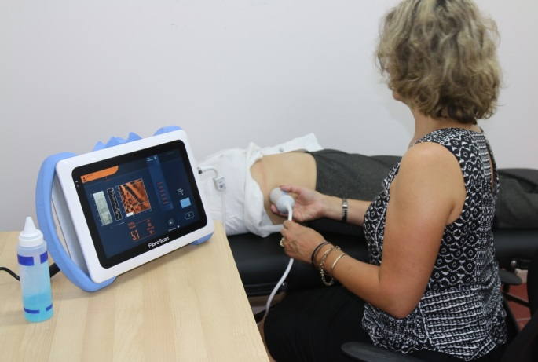
You have been referred by your doctor Dr.___________________________________________ to have a FibroScan® procedure with ECCQ. At ECCQ we provide FREE FibroScan® to check for potential damage to the liver caused by chronic hepatitis.
FibroScan® is a fast and painless type of ultrasound test of the liver performed by a trained operator. A bilingual community health care worker will usually be available to help with any questions you may have. Alternatively, an interpreter may be required to assist. Your doctor will discuss the result with you at your next appointment.
It is VERY important to have regular check-ups with your doctor and to have any tests which they may request if you have chronic hepatitis. Even if you feel well.
On the day of your FibroScan® you must:
- NOT EAT for 3 hours before your test. You can drink sips of water only.
Eating and drinking can affect the result.
- Wear comfortable clothing (skirt/pants and top) as the test is performed over your ribs on the right hand side.
- You must let us know before the test if you have a pacemaker or internal defibrillator in your heart.
- You must be over 18 years old to have this test.
Your appointment has been booked for:
Date: Day: Time:
Where:

It is important that you let the clinic know if you cannot come on this day.
If you have any questions about FibroScan® you can contact our ECCQ community health workers: 3844 6877 / 0479 130 997 for Chinese; 3844 3122 / 0428 223 052 for Vietnamese; or 3255 1540 Ext 214 for English and other languages.
Funding for this project provided by Queensland Health
FibroScan® with ECCQ

Client Name:__________________________________________________________________
You have been referred by your doctor Dr.___________________________________________ to have a FibroScan® procedure with ECCQ. At ECCQ we provide FREE FibroScan® to check for potential damage to the liver caused by chronic hepatitis.
FibroScan® is a fast and painless type of ultrasound test of the liver performed by a trained operator. A bilingual community health care worker will usually be available to help with any questions you may have. Alternatively, an interpreter may be required to assist. Your doctor will discuss the result with you at your next appointment.
It is VERY important to have regular check-ups with your doctor and to have any tests which they may request if you have chronic hepatitis. Even if you feel well.
On the day of your FibroScan® you must:
- NOT EAT for 3 hours before your test. You can drink sips of water only.
Eating and drinking can affect the result.
- Wear comfortable clothing (skirt/pants and top) as the test is performed over your ribs on the right hand side.
- You must let us know before the test if you have a pacemaker or internal defibrillator in your heart.
- You must be over 18 years old to have this test.
Your appointment has been booked for:
Date: Day: Time:
Where:

It is important that you let the clinic know if you cannot come on this day.
If you have any questions about FibroScan® you can contact our ECCQ community health workers: 3844 6877 / 0479 130 997 for Chinese; 3844 3122 / 0428 223 052 for Vietnamese; or 3255 1540 Ext 214 for English and other languages.
Funding for this project provided by Queensland Health

